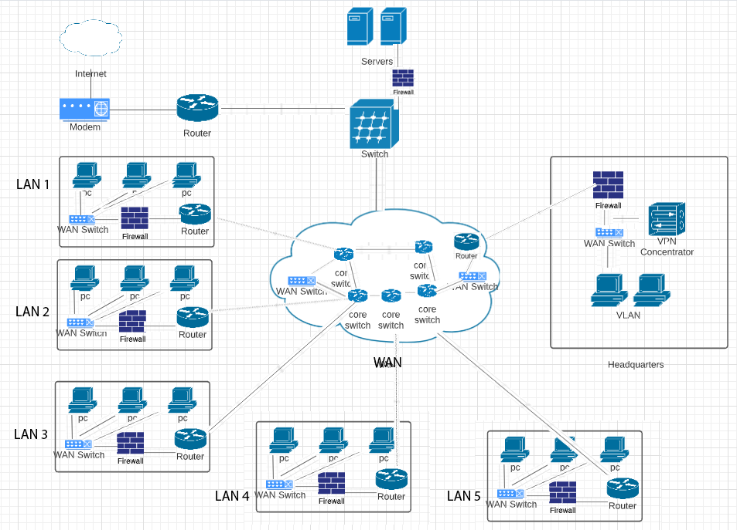

Devices | Protection | How protection will be provisioned
Firewall | Malicious access to the network (private) including viruses and worms | Network filtering of packets. All incoming and outgoing traffic is closely monitored by the firewall to ensure outbound and inbound rules are enforced.
VPN Concentrator | Avoid unauthorized access to the VLAN network or else a VPN (Virtual Private Network) | Data encryption between the two networks and User based authentication protocols
Server | Unauthorized access to the personal computers or desktops in the network. | The use of active directory ensures only registered users of the network can use the computers in the network.

